**Guide: Initiating a New Workflow with Script in DAS ware Control Application**

**Step 1:** Ensure you are on starting page of the DAS ware control application.

**Step 2:** Select the “New Workflow” button located in the top left corner.

**Step 3:** Choose the template titled “Cell Cultivation: pH Control (FCO2/base); DO Control (Fair, FO2).”

**Step 4:** Utilize the slider to select the desired number of reactors for your experiment.



**Step 5:** Click “Next” to proceed to the following page.

**Step 6:** If the number of units and unit numbers are satisfactory, name your experiment in the field labeled “Identifier.” Click “Save and Start.”

**Step 7:** Confirm you are directed to the appropriate page, ensuring all prior steps were executed correctly.

**Step 8:** If all information is accurate, press the “Start” button.

**Step 9:** Observe the duration timer is active under “Vessel.”

**Step 10:** Click on the previously selected reactor.

**Step 11:** Review all setup information displayed for the selected reactor.

**Step 12:** Select the “Vessel” widget.

**Step 13:** Navigate to the “Scripting” page.

**Step 14:** In the “Scripting” tab, click “Open editor.”

**Step 15:** This will direct you to the Script editor. You will now acquire the necessary script.

**Step 16:** Utilize the shortcut icon in the taskbar to access the relevant Confluence page.



**Step 17:** This shortcut should bring you to this confluence page.

**Step 18:** In the “Page Tree,” expand the “Eppendorf BRX” tab and select “CCD Scripts and Templates.”

**Step 19:** Access the “Script Generator Automator” tab from there.

**Step 20:** Now you should see the “Feed Script Form”.

**Step 21:** Fill out the “Feed Script Form” with details such as the amount of “Feed A” and “Feed B” to be syphoned into the bioreactor on specific days.

**Step 22:** Ensure your experiment is named, note the “Experiment ID,” and input the bioreactor IDs under “BRX ID.”

**Step 23:** Submit the form using the “Submit” button at the bottom of the “Feed Script Form.”

**Step 24:** The form will appear under the download’s icon.

**Step 25:** Click on the text (.txt) file to open it.

**Step 26:** Make sure you select the whole text file and copy it to your clipboard (Ctrl + c).

**Step 27:** Return to the script editor you opened (from step: 15) and paste the whole script from your clipboard (Ctrl + v).

**Step 28:** When pasted hit the “Compile” button.

**Step 29**: The message output box should say: “Compilation successful”, you can now hit the “Confirm” button.

**Step 30:** You are now ready to start the inoculation timer. Confirm the system status in the event box reads “Scale is busy” and “Automated feeding initialized for unit#: Unit 4.”

**Step 31:** Select the “Offline” widget. 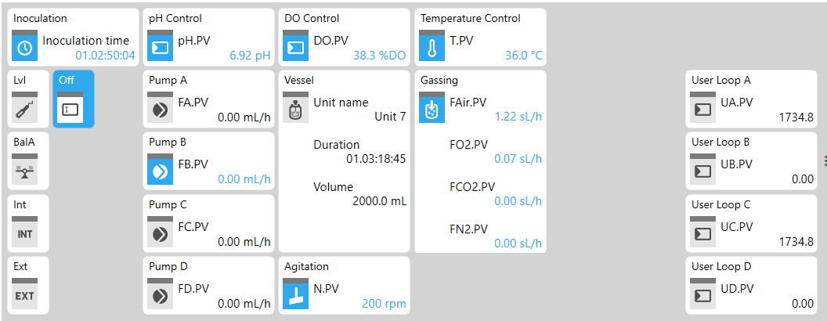

**Step 32:** On each feed day, you must write the process day and the glucose amount needed to be fed (either “x” amount or 0), to confirm that sampling has been done. If the needed values aren’t present, feeding without glucose will be carried out regardless, but 2 hours after the set feed time. (On non-feed days, there may be a warning stating that the sample hasn’t been confirmed.)

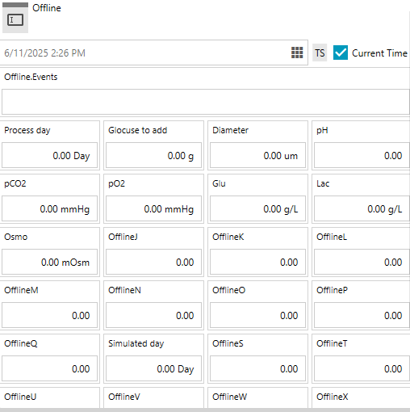

**Step 33:** After sampling has been confirmed and the feeding has been carried out, you may select the “Internal” widget.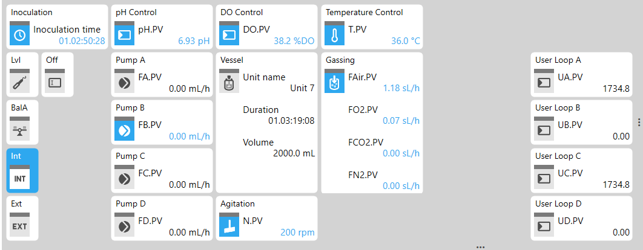**Step 34:** Here you can see the target feed amount for all feeds (Feed A, Feed B, Glucose) and the actual amount fed.

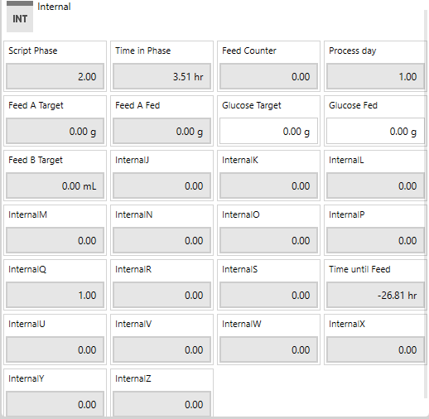

Tubing Information

Feed A Tubing (2mm) - P/N BP-DG-BIO-002, S/N 10241768; F.Cal= 15.92 1/mL

Feed B Tubing (0.5mm) - P/N BP-DG-BIO-013_A; F.Cal= 105 1/mL

Glucose Tubing (1mm) = P/N BP-DG-BIO-001, S/N 10250723; F.Cal= 24 1/mL